|  |  |  |  |  |  |
| --- | --- | --- | --- | --- | --- |
| Date | 28-Nov-22 | | | Tester Name | Janette Paus |
| Environment | Penfax - Test 2 | | | Login used | <If different from the Tester> |
| Operating System | Windows | Version: 21H2 | Update Number: | | |
| Software Used | Edge | Version: 107.0.1418.56 | Update Number: | | |
| Select Software | Version: | Update Number: | | |
| Application Release version | R22.4.1 | | | | |
| Test Case Title | E 18.02 | | | | |
| Test Type | Regression | | | | |
| Test Scenario | Non-Resident Payment Australia | | | | |
| Expected Results | That the payment will process, tax will be deducted at a rate of 15% and that the wire transfer can be added and will process correctly. | | | | |
| Pass/Fail | Select | | | JIRA# | <enter the new JIRA ticket number if the test case failed> |

Search for a person in the country Australia with money in their PEPP Account:

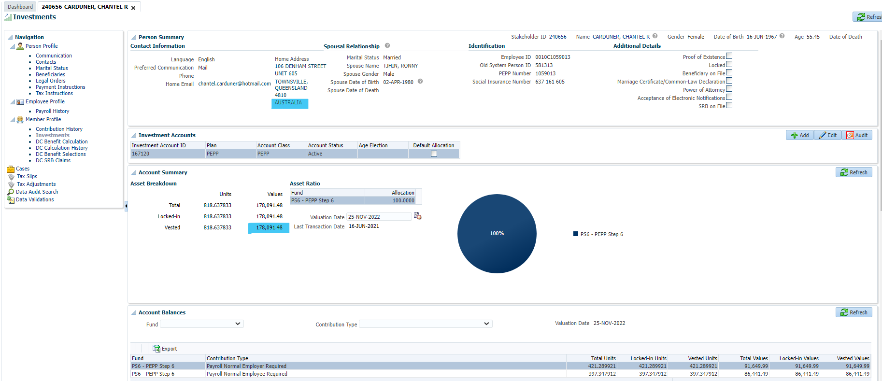

Check employment period for End Date:

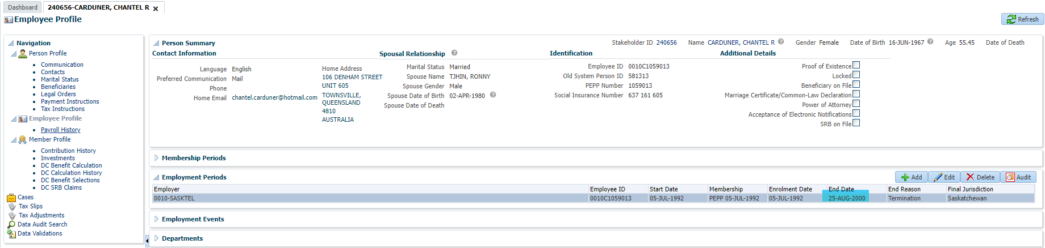

Add DC Benefit Selection, enter retirement date as current date as member is over 50 years, click Next:

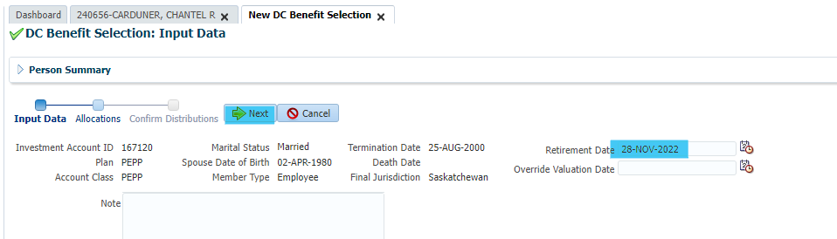

Process payment for 100% of account to non-resident cash, click Save and Next:

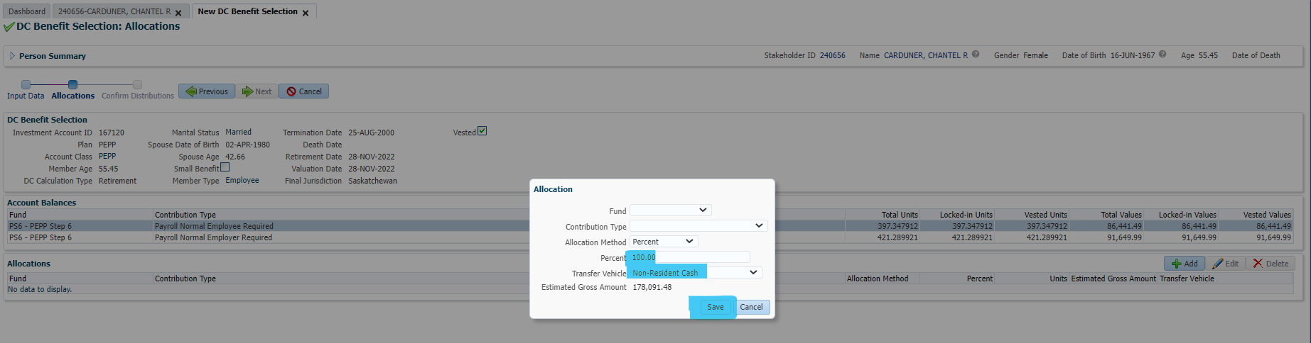

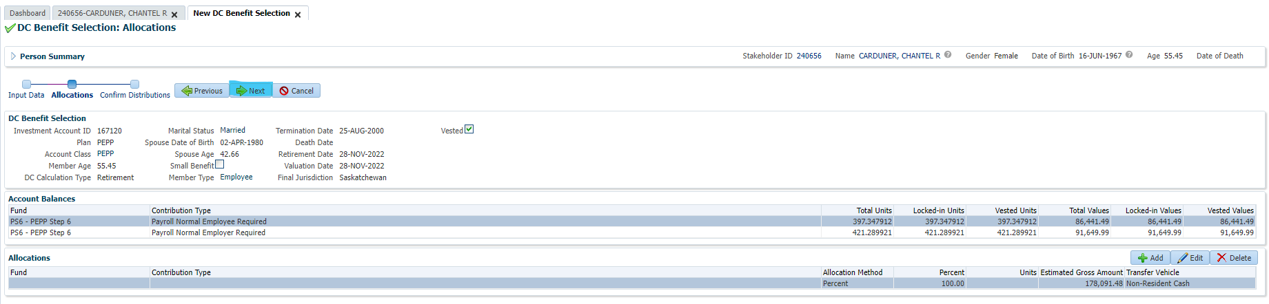

Add Payment Instruction (adding wire transfer) – using PEBA EFT:

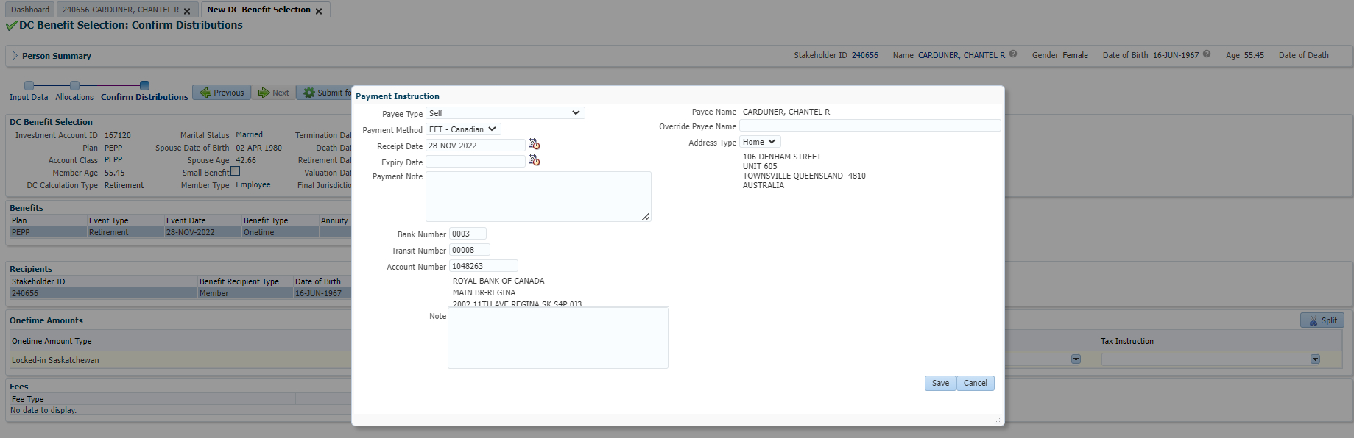

Add Tax Instruction (change the Taxation Country to Australia), click Save:

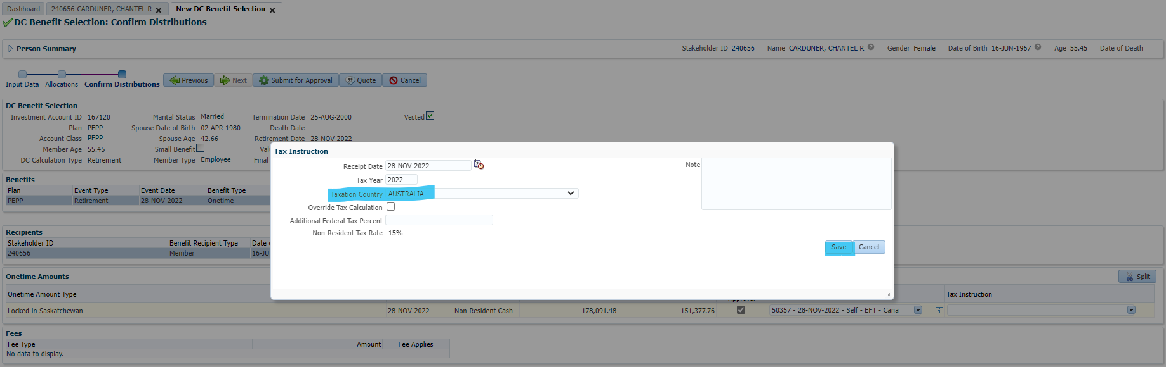

Confirmed Taxes on DC Benefit screen, Australia is 15%:

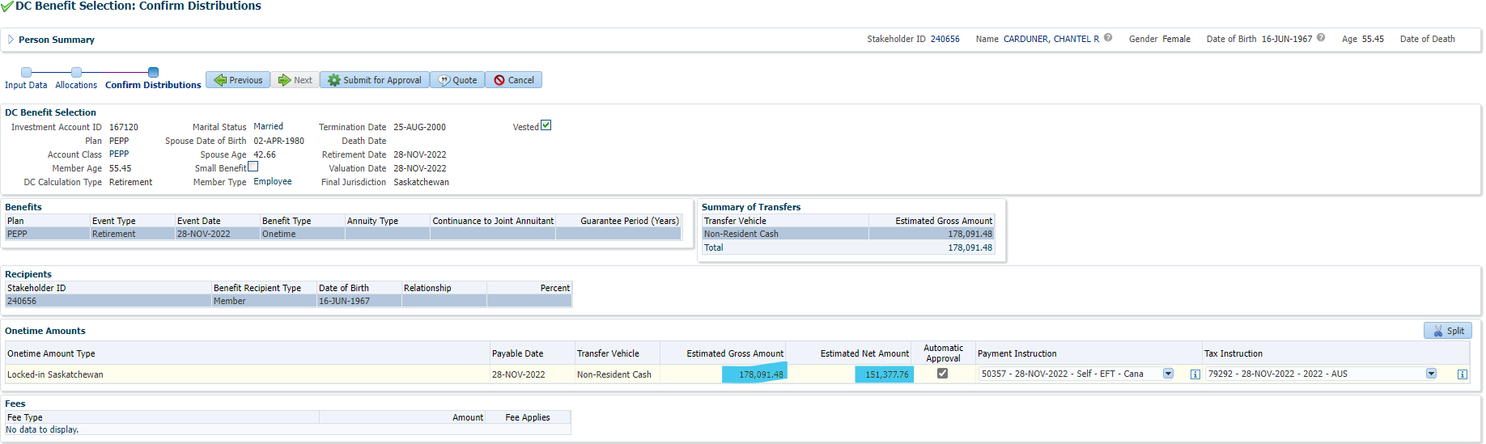

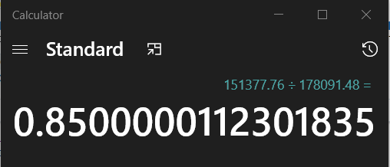

Confirm 15% is the correct tax by going to Plan Rules 🡪 Tax Rates 🡪 Federal Non-Resident Lump Lum Tax, find Australia:

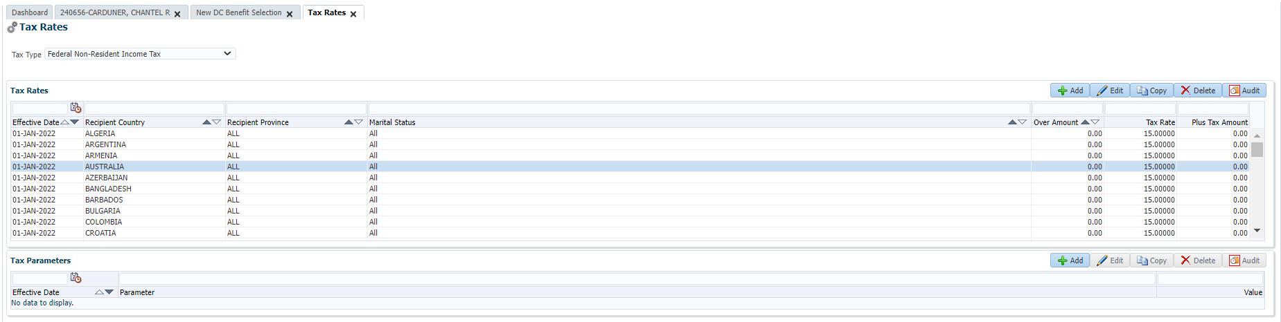

Unclick Auto Approval (to add wire transfer fee after PIT batch runs):

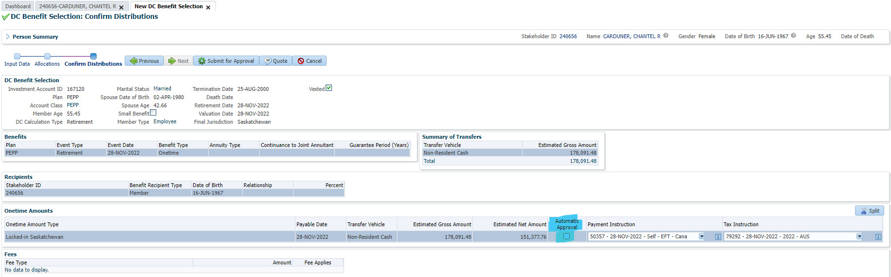

Click Submit for Approval:

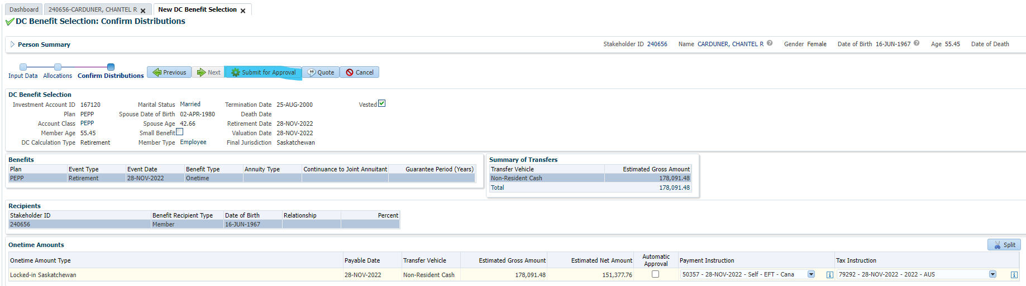

Click Approve:

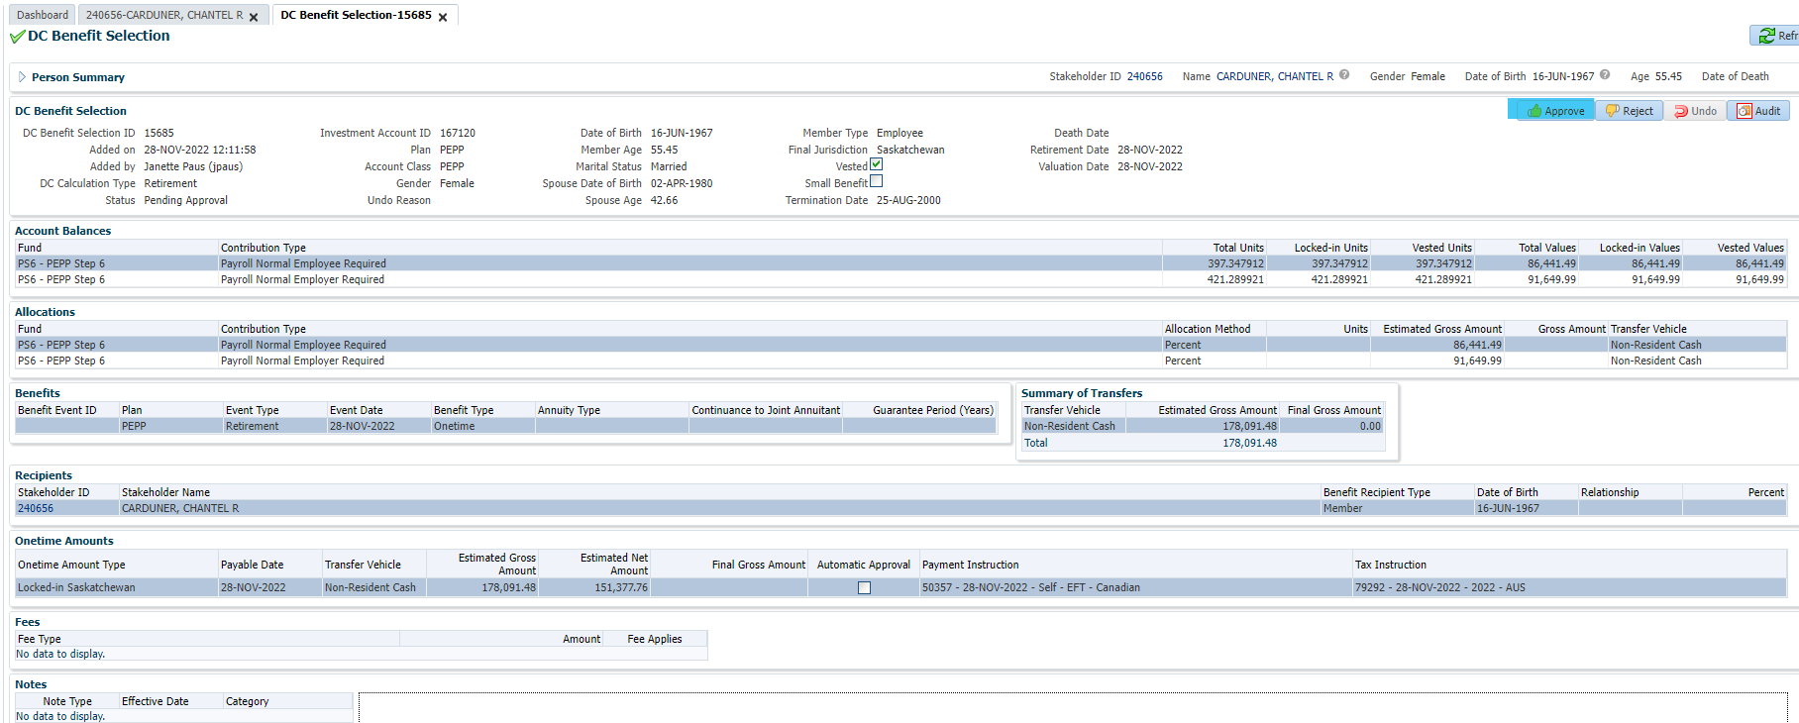

Next day:

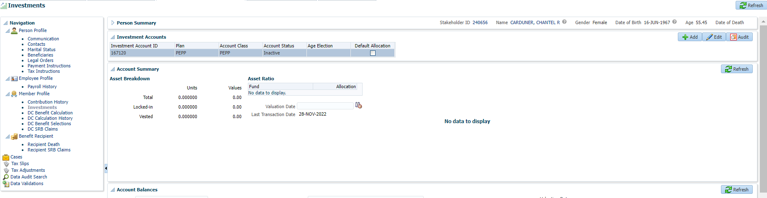

Funds were removed from PEPP account under investments

Click search under account activity to show unit valuation & activity.

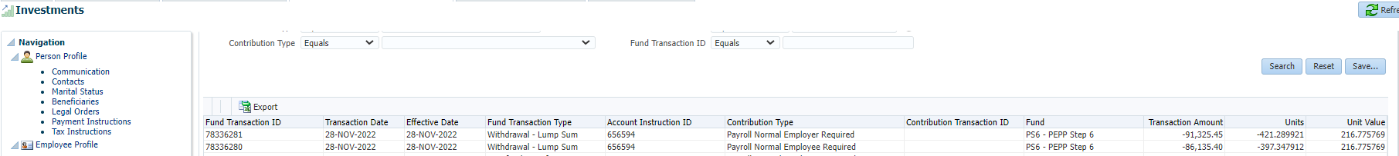

Click on benefit recipient & one time amounts to check status (should show as new and not approved for a wire transfer)

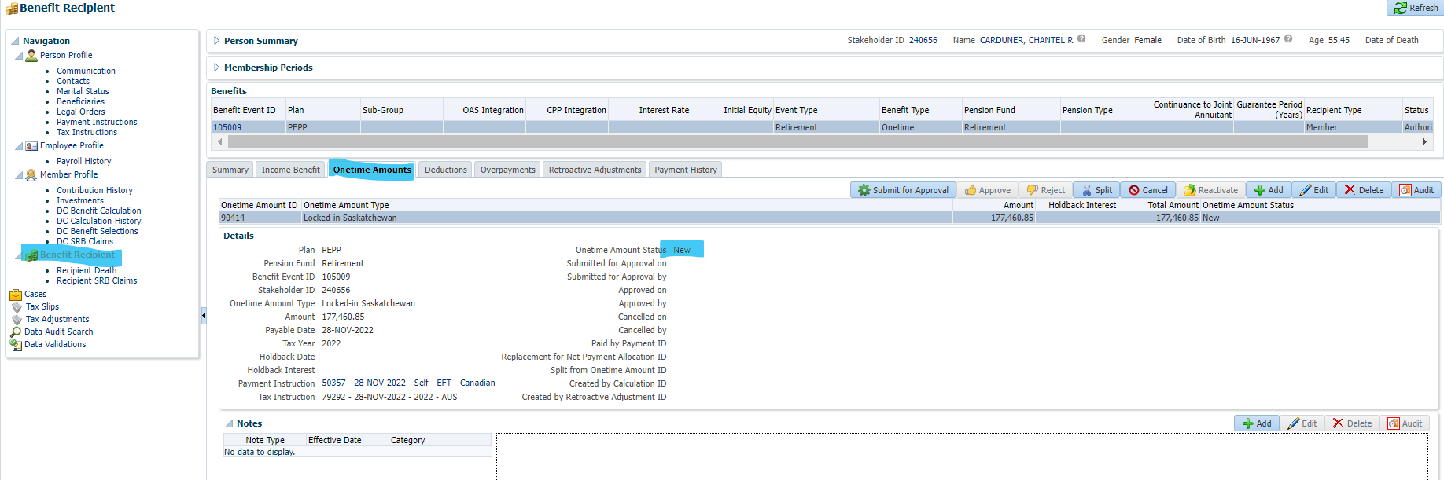

Add wire transfer fee, click on deductions & add.

Then enter deduction type, fill in the one time amount field and enter the amount of the fee. Then save.

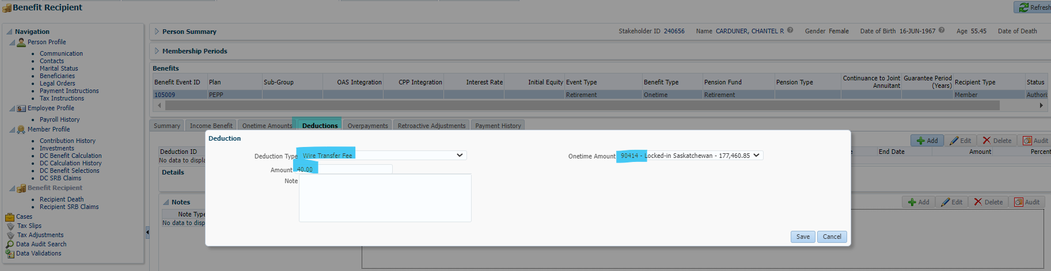

Go back to the one time amount tab and hit submit for approval & then approve.

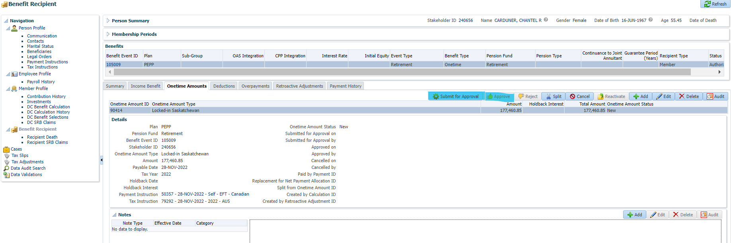

Now shows as approved, paid by payment ID will be filled in next day can confirm taxes are allocated correctly: